**Network Topology**

Name of VM 1: Capstone

Operating System: Ubuntu

Purpose: Vulnerable Web Server

IP Address: 192.168.1.105

Name of VM 2: Kali

Operating System: Kali Linux

Purpose: Penetration Tester

IP Address: 192.168.1.90

Name of VM 3: ELK

Operating System: Ubuntu

Purpose: Elasticsearch and Kibana

IP Addres: 192.168.1.100

Name of VM: Target 1

Operating System: Linux

Purpose: Target Machine

IP Address: 192.168.1.110

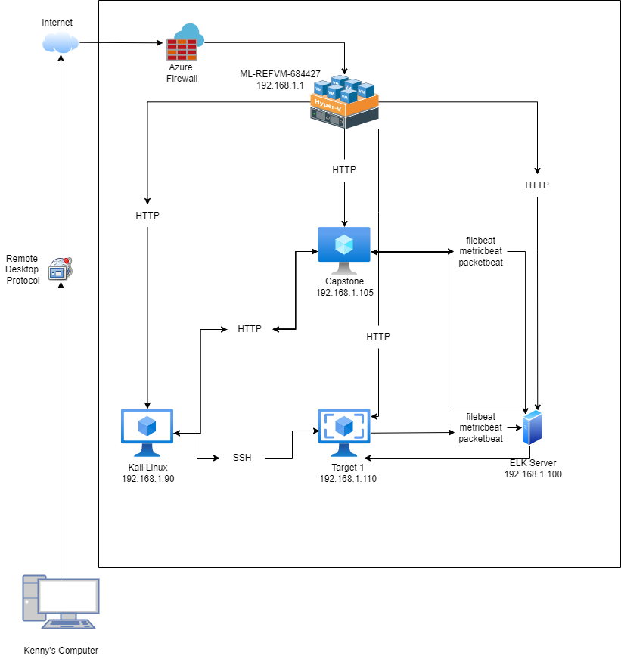

**Description of Targets**

The target of this attack was: Target 1 (192.168.1.110)

Target 1 is an Apache web server and has SSH enabled, so ports 80 and 22 are possible ports

of entry for attackers. As such, the following alerts have been implemented:

**Monitoring the Targets**

Traffic to these services should be carefully monitored. To this end, we have implemented the

alerts below:

**Excessive HTTP Errors**

Excessive HTTP Errors is implemented as follows:

**Metric**: WHEN count() GROUPED OVER top “http.response.status_code”

**Threshold**: 400 for the last 5 minutes

**Vulnerability Mitigated**:Brute Force Attacks and Enumeration

**Reliability**: It is highly reliable because it filters out normal activity. Codes 400 and above are are client and server error responses which are ones that should be closely monitored especially when there is a higher frequency of them.

**CPU Usage Monitor**

CPU Usage Monitor is implemented as follows:

**Metric**: WHEN max() OF “system.process.cpu.total.pct” OVER all documents

**Threshold**: above 0.5 for the last 5 minutes

**Vulnerability Mitigated**: possible malware or viruses

**Reliability**: This is rated medium on reliability. Though this threshold will definitely monitor any suspicious activity, it might also pick up daily activities that might consume more CPU power on occasions.

**HTTP Request Size Monitor**

HTTP Request Size Monitor is implemented as follows:

**Metric**: WHEN sum() of http.request.bytes OVER all documents

**Threshold**: above 3500 for the last minute

**Vulnerability Mitigated**: Cross Site Scripting or DDos attacks

**Reliability**: This alert is a medium reliability because it can create false positives. It could be regular use of HTTP requests or traffic.